**PETSTORE LOAD TEST REPORT**

**Summary**

In this test a load of 45 concurrent users applied on PetStore application which is deployed to Azure VM having 16 CPUs and 64 GB Memory.

|  |  |
| --- | --- |
| Project & Environment | PetStore |
| Load Test Date | 7th May 2024 |
| Load Test Duration | 6 Minutes |
| # Concurrent Users | 45 |
| Scenarios | 3 |
| Application Version | v.1.2 |

**Scenarios Considered for Load Testing**

|  |
| --- |
| Scenarios |
| Register and Login to PetStore |
| Add Items to Cart |
| Add Items to cart and Order |

**Average Response Time of Different Transactions**

|  |  |
| --- | --- |
| Transactions | Average Response Time (in Sec) |
| Launch PetStore | 0.9 |
| Navigate to Catalog Page | 0.2 |
| Navigate to Sign-In Page | 0.1 |
| Navigate to Register Page | 0.1 |
| Save Account Information | 0.6 |
| Login to Application | 0.5 |
| Navigate to My Accounts Page | 0.1 |
| Navigate to Product Page | 0.1 |
| Navigate to Items Page | 0.1 |
| Navigate to Add to Cart Page | 0.1 |
| Add Item to Cart | 0.1 |
| Update Cart | 0.1 |
| Proceed to Checkout | 0.1 |
| Continue with Billing Details | 0.6 |
| Confirm Order | 0.2 |
| Navigate to My Orders Page | 0.2 |
| Logout from Application | 0.5 |

**Note:** For metrics of all transactions in each scenario, please go through excel file.

**App Server Details**

|  |  |
| --- | --- |
| IP Address | 123.4.5.67 |
| Server Size | D16as_v4 |
| Memory Size | 64 GB |
| Disk Capacity | 512 GB |
| Server Virtual Processors | 16 |

Note: As we don’t have access to app server, included infrastructure usage of my local machine.

**CPU Usage of App server**

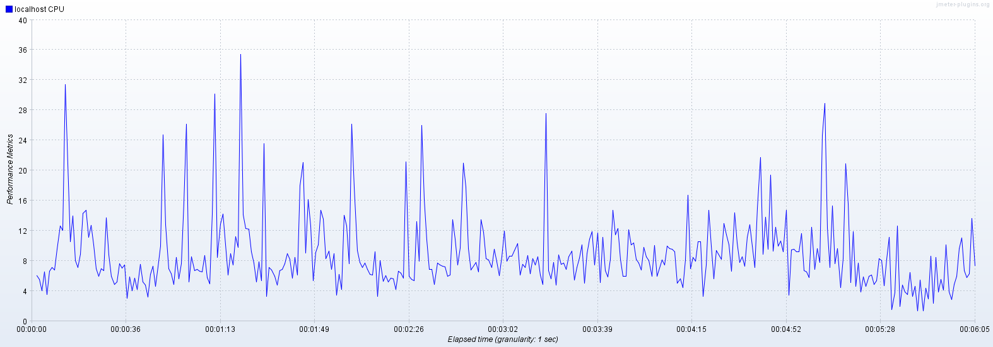

Observation: CPU utilization of app server is normal.

**Memory Usage of App server**

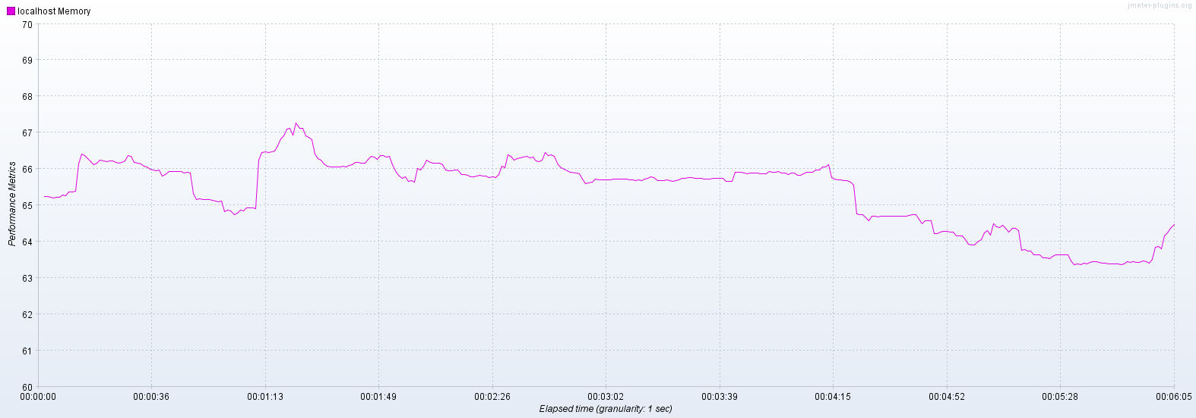

Observation: Memory utilization of app server is increasing with load on the application.

**Disk I/O Read bytes**

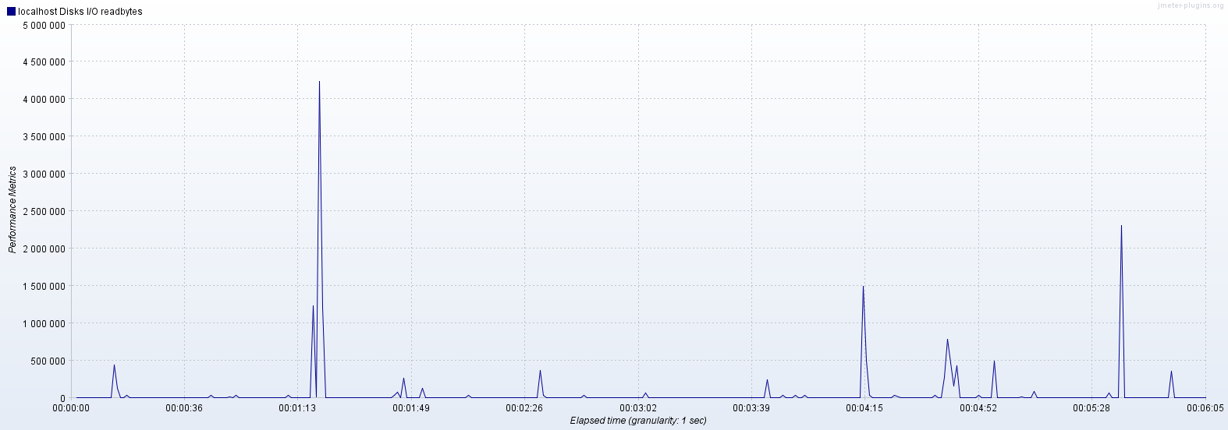

Observation: Disk I/O reads rate is normal.

**Disk I/O Write bytes**

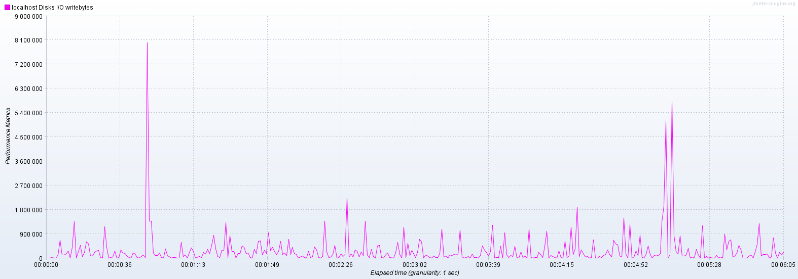

Observation: Disk I/O writes rate is normal.

**Active Users Over Time**

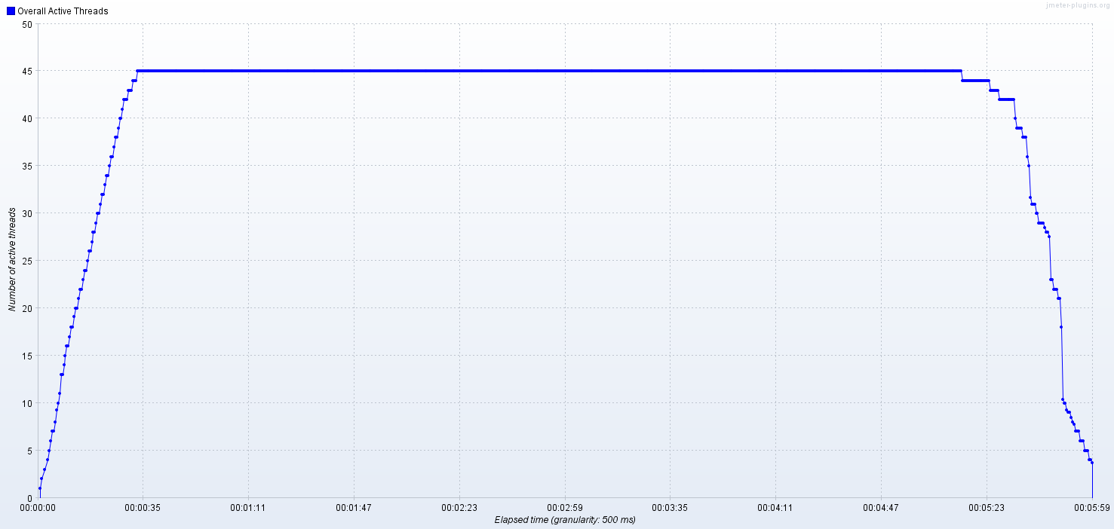

**Transactions Per Second**

**Overall Response Time**

**Bytes Throughput Over Time**

**Overall observation:** Performance of the application is good with 45 concurrent user load on the application. Infrastructure usage of the application server is normal.